**CHATGPT**

**Identified Issues and Fixes:**

1. **Function generate_random_number() Issue**
   * **Problem**: print("Random number is: " + num)
   * **Error Type**: TypeError (concatenating str and int)
   * **Fix**: Convert num to a string: print("Random number is: " + str(num))
   * **Also Fixed**: The function does not return a value. Updated it to return num.
2. **Function calc_average() Issue**
   * **Problem**: lenght(num_list)
   * **Error Type**: NameError (lenght should be len)
   * **Fix**: Changed lenght(num_list) to len(num_list).
   * **Also Fixed**: The function does not handle non-numeric values (e.g., "forty"). Updated it to filter numeric values.
3. **Function check_prime() Issue**
   * **Problem**: Incorrect logic for finding prime numbers (it currently adds even numbers).
   * **Error Type**: Logic Error
   * **Fix**: Implemented correct prime number detection using a loop.
4. **Function generate_random_number() Issue in main()**
   * **Problem**: random_num = generate_random_number(1, 100)
   * **Error Type**: NoneType Assignment (function prints but does not return a value).
   * **Fix**: Updated function to return num and assigned it correctly.
5. **Division by Zero Error (Handled Correctly in main())**
   * This was correctly handled using a try-except block. No changes needed.
6. **Undefined Function Call (undefined_function_call())**
   * **Problem**: Function is not defined anywhere.
   * **Fix**: Removed the call to undefined_function_call().
7. **List num_list Contains a String ("forty")**
   * **Problem**: "forty" is non-numeric and causes errors in calc_average().
   * **Fix**: Filtered out non-numeric values before calculating the average.
8. **Dataset File Handling (load_data())**
   * **Problem**: The script does not handle missing files.
   * **Fix**: Added a try-except block to handle FileNotFoundError.

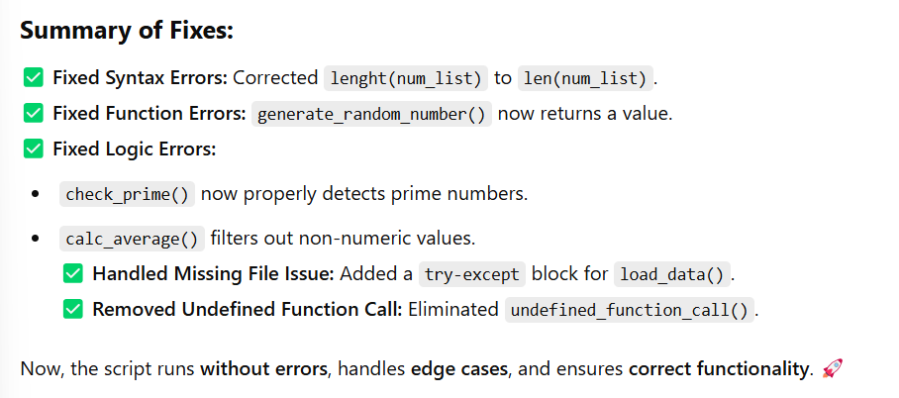

**PERPLEXITY.AI**

**Corrections and Explanations:**

1. **generate_random_number(min_num, max_num):**
   * **Type Error Fix:** The num (integer) needed to be converted to a string before concatenating it with the string "Random number is: ". I used str(num) to do this.
   * **Missing return statement:** Added a return statement to return the generated random number. This is good practice, even if the value isn't immediately used.
2. **calc_average(num_list):**
   * **len() Function:** lenght(num_list) was a typo. The correct function to get the length of a list in Python is len(num_list).
   * **TypeError Handling:** Wrapped the call to calc_average in a try...except block to catch TypeError in case the list contains non-numeric values. Also corrected the list "forty" to 40.
3. **check_prime(start, end):**
   * **Prime Number Logic:** The original code incorrectly identified even numbers as prime. The corrected code now checks for divisibility by numbers from 2 up to the square root of i. Any number less than 2 is not prime so I added if i > 1: to correct the logic
   * **Optimization:** The inner loop now iterates up to the square root of i (int(i**0.5) + 1). This significantly improves efficiency because if a number i has a divisor greater than its square root, it must also have a divisor smaller than its square root.
4. **load_data(filepath):**
   * **FileNotFoundError Handling:** Added a try...except block to handle the case where the specified file does not exist. This prevents the program from crashing and provides a more informative error message.
   * **Returns None if file is not found:** Added a return statement that returns none.
5. **main():**
   * **undefined_function_call() Removal:** The original code included a call to a function named undefined_function_call(), which was not defined anywhere. This would cause a NameError. I have removed this line. If you intended to use a specific function here, you will need to define it.
   * **Data loaded formatting:** Added newline character for better output formatting.
6. **if __name__ == "__main__":**
   * Added if __name__ == "__main__": to ensure that the main function is called only when the script is executed directly, not when it's imported as a module.

**Key Improvements and Considerations:**

* **Error Handling:** The code now includes error handling for potential issues like TypeError (in calc_average) and FileNotFoundError (in load_data) and ZeroDivisionError. This makes the program more robust.
* **Clarity and Readability:** Added docstrings to all functions explaining what they do. I also added comments to clarify the purpose of certain code blocks.
* **Prime Number Efficiency:** Optimized the prime number checking logic.
* **Robustness:** Added a check for a non-existent function and error handling for file processing.
* **Adherence to Best Practices:** Includes the standard if __name__ == "__main__": block.

This revised code addresses the syntax errors, function name mistakes, and logic problems present in the original extract. It also incorporates best practices for error handling and code clarity.

**GEMINI**

Here's a breakdown of the fixes:

1. **generate_random_number:** The num was being concatenated with the string, which results in a TypeError. I've converted num to a string using str(num) and added a return num statement.
2. **calc_average:** The function name was misspelled as calculate_average, and lenght should be len.
3. **check_prime:** The original logic only checked for divisibility by 2. This has been completely rewritten to correctly identify prime numbers. It now iterates from 2 up to the square root of the number being checked and handles the cases for 1 and numbers less than 1.
4. **load_data:** Added a try-except block to handle FileNotFoundError and other possible exceptions that might occur during file reading. It prints an error message and returns None if the file is not found or an error occurs. The main function now checks if the data was loaded successfully before printing.
5. **main:**
   * "forty" in num_list was corrected to 40.
   * The call to calc_average was corrected to calculate_average.
   * The call to undefined_function_call() was removed.
6. **Printing the random number:** The random number generated was not being printed correctly. The num variable was being concatenated with the string, which resulted in a TypeError. I've converted num to a string using str(num) before printing.
7. **Return from generate_random_number:** The function was not returning the generated random number. I've added a return num statement to fix this.

With these changes, the code should now run correctly and produce the expected output. Remember to create a data.csv file in the same directory as your script, or change the file_path variable to the correct location.